**Scatterplot Matrix**



**Pairwise Correlations**

| **Variable** | **by Variable** | **Correlation** | **Count** | **Lower 95%** | **Upper 95%** | **Signif Prob** |  |
| --- | --- | --- | --- | --- | --- | --- | --- |
| Height | Drop | 0.7492 | 78 | 0.6320 | 0.8329 | <.0001* |  |
| Duration | Drop | 0.4326 | 78 | 0.2324 | 0.5976 | <.0001* |  |
| Duration | Height | 0.3413 | 78 | 0.1286 | 0.5241 | 0.0022* |  |
| Speed | Drop | 0.9211 | 78 | 0.8787 | 0.9491 | <.0001* |  |
| Speed | Height | 0.7640 | 78 | 0.6523 | 0.8431 | <.0001* |  |
| Speed | Duration | 0.3918 | 78 | 0.1854 | 0.5651 | 0.0004* |  |
| Length | Drop | 0.5328 | 78 | 0.3519 | 0.6752 | <.0001* |  |
| Length | Height | 0.4209 | 78 | 0.2189 | 0.5884 | 0.0001* |  |
| Length | Duration | 0.8009 | 78 | 0.7038 | 0.8686 | <.0001* |  |
| Length | Speed | 0.5025 | 78 | 0.3152 | 0.6521 | <.0001* |  |
|  |  |  |  |  |  |  |  |

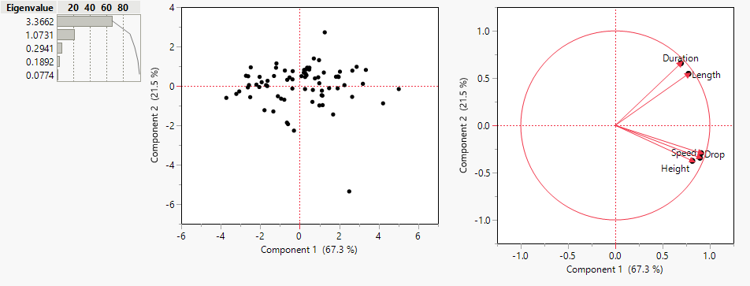

**Eigenvectors**

|  | **Prin1** | **Prin2** | **Prin3** | **Prin4** | **Prin5** |
| --- | --- | --- | --- | --- | --- |
| Duration | 0.37793 | 0.63408 | 0.13306 | 0.65994 | 0.04338 |
| Speed | 0.48786 | -0.33053 | -0.37551 | 0.06709 | 0.71220 |
| Height | 0.44362 | -0.36196 | 0.81625 | -0.06855 | -0.03504 |
| Drop | 0.49444 | -0.28315 | -0.41437 | 0.11845 | -0.69973 |
| Length | 0.42178 | 0.52678 | -0.05765 | -0.73570 | -0.00553 |